***REGISTRATION FORM***

**Defenses, Dichotomies, & Character Structure**

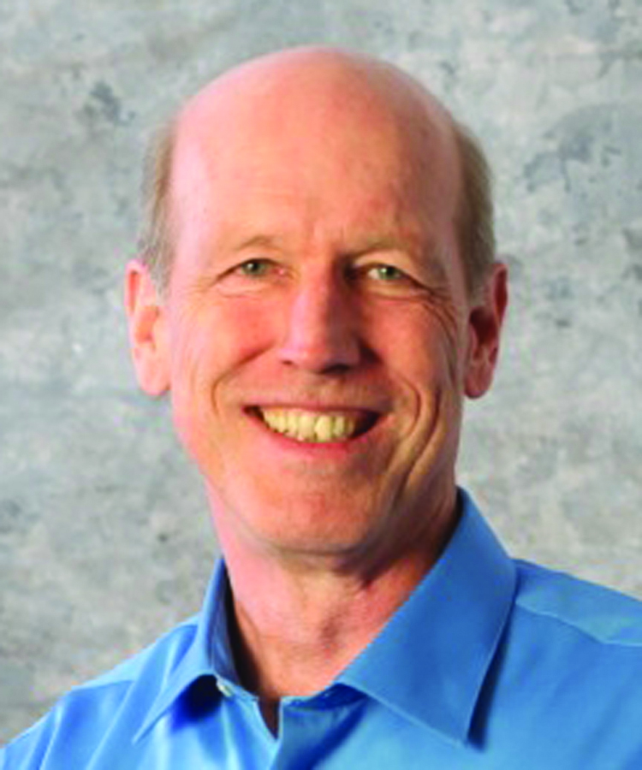**with Peter O’Hanrahan**

**November 14 & 15, 2015**

**Seattle, WA**

***(Please print!)***

**Name ____________________________________________ Type ________ Subtype _____________**

**Address ______________________________________________________________________________**

**City/State/Zip _____________________________________________________________________________________**

**Phone (home) __________________________________________**

**(mobile) _________________________________________**

**E-Mail _______________________________________________________________________________**

**Registration Fee: $245 (Early Bird) _________ $275 (After October 16th) _________**

**TO REGISTER for this workshop:**

**Please fill out this registration form and mail or email the information to:**

***REGISTRATION FORM***

|  |
| --- |
| **TO REGISTER**  **Make check payable to:**  **Emile Haddad, 9016 Meridian N,  Seattle WA 98103**  **FOR MORE INFORMATION:**  [**emile@catalystbcc.com**](mailto:emile@catalystbcc.com)  [**nshama.sterling@gmail.com**](mailto:nshama.sterling@gmail.com) |
| **Saturday, November 14    9:00am - 6:00pm**  **Sunday, November 15       9:00am - 6:00pm**  **The Mountaineers**  **7700 Sand Point Way NE, Seattle, WA 98115**  **WORKSHOP COST:**  **Early Bird $245   (by October 1, 2015)**  **Regular    $275** |

**Defenses, Dichotomies, & Character Structure**

**with Peter O’Hanrahan**

**November 14 & 15, 2015**

**Emile Haddad, 9016 Meridian N, Seattle WA 98103, emile@catalystbcc.com**

|  |  |
| --- | --- |
| **Saturday, November 14 9:00am - 6:00pm**  **Sunday, November 15 9:00am - 6:00pm**  **The Mountaineers**  **7700 Sand Point Way NE, Seattle, WA 98115**  **WORKSHOP COST:**  **Early Bird $245 (by October 16, 2015)**  **Regular $275** | **TO REGISTER**  **Make check payable to:**  **Emile Haddad, 9016 Meridian N, Seattle WA 98103**  **FOR MORE INFORMATION:**  **emile@catalystbcc.com**  **nshama.sterling@gmail.com** |