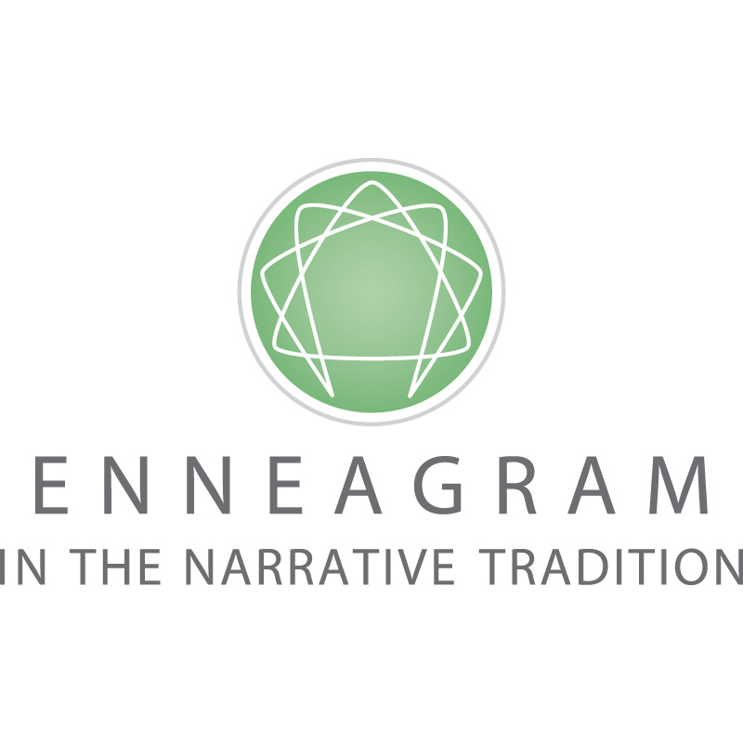

Transforming lives. Creating a more compassionate world.

DAVID DANIELS LEGACY FUND DONATION
I would like to contribute the following amount to ESNT: $ .

FREQUENCY (Select One)
One-Time Monthly Annually

PAYMENT INFORMATION
Name
Company/Organization
Address
City/State/Zip
Telephone Email
For public recognition, please list my name as:

Enclosed is my check made out to ESNT for $

Please charge my credit card in the amount of $
Circle One: Amex Visa Mastercard
Card#
Exp Date CVS
Signature

Send to:
ESNT
Attn: Mary A. Freund
1942 Broadway, Suite 408, Boulder, CO 80302

Or contact Mary at:
866-241-6162, ext. 711
or mary@enneagramworldwide.com

ESNT is a nonprofit organization and is tax exempt under Section 501(c)3 of the Internal Revenue Code. The entirety of your contribution may be tax-deductible. Check with your tax advisor.

