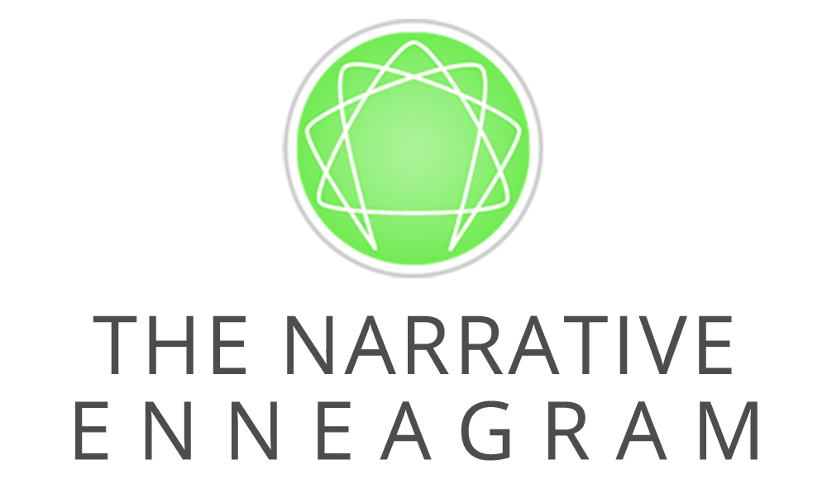
ENNEAGRAM INTENSIVE – PART 1

October 25-27, 2019 – Denver, CO

Note: You also may register and pay online at www.EnneagramWorldwide.com.

Name__________________________________________________________________________
Address ________________________________________________________________________

City/State/Zip ___________________________________________________________________

Profession _________________________Email ________________________________________

Enneagram type ___________________ Subtype (if known) _____________________________
Phone (h) ______________________(w) _____________________ (c) _____________________
Emergency contact _________________________ Phone(s) ______________________________
Name you prefer on badge__________________________________________________________
Meals: Food allergies/what kind _____________________ Vegan __ Vegetarian __Other _______
How did you hear about us? Friend or family (Enter name) ________________________________
Website Email Mailing Ad Workshop Therapist Other (Name)__________
DISCOUNTS, TUITION + SITE FEES
Early-bird discount: Register by September 27, 2019 and save $60.
If you register for Part 2 on the same day, save an additional $60 on Part 2.

Are you eligible for one of these discounts? Note: discounts below cannot be combined.
- Students: Full-time students with ID currently enrolled in a school, college or university save $75 off either early-bird or standard tuition.
- Bring-a-friend: Save $25 off either early-bird or standard tuition when you and a friend register at the same time.
- Repeaters: If you are repeating the Enneagram Intensive, you are eligible for a discounted tuition of $300 (50% of the standard rate) + standard $200 site fee (cannot be combined with early-bird or other discounts) = $500.

Early-bird by September 27: $740 OR After September 27: $800
Students: Deduct $75 OR
Friends: Deduct $25 Friend’s name ____________________________ OR
Repeater: $500

TOTAL AMOUNT DUE __________
Paid in full OR $500 deposit: __________

For group discounts, or to apply gift certificates, please call Registrar at 866-241-6162 ext. 1 or
+1 303-305-4362 outside the U.S.
PAYMENT METHOD
Today’s Date ____________ Name __________________________________________________

Check payable to “TNE”: Check Number _____________ Amount ________________________
OR
Send me a PayPal invoice
OR
Credit Card: Visa Mastercard Amount _______________________________________
Name on Card _______________________________________ Exp Date _________________
Card Number _________________________________________________________________
Security code (3 numbers on signature space on back of card) __________________________
DEPOSIT, DISCOUNT, CANCELLATION AND REFUND POLICY

Also available at www.enneagramworldwide.com/cancellation-policy/
The following deposit, discount, cancellation and refund policy is in effect for all trainings, workshops, learning communities and internships produced by The Narrative Enneagram. Events not produced by TNE are governed by the policy of the producer, so please check with them directly for their policies.

DEPOSITS
Upon registering for TNE trainings, a $500 deposit is required for the EI, with a $300 deposit required for all other trainings, including the Learning Communities, with the outstanding balance to be paid 21 days prior to the date of the training.

DISCOUNTS
Applicable discounts are listed on the TNE website, on each individual registration form.

CANCELLATIONS & REFUNDS
Sponsor Cancellation
- TNE reserves the right to substitute faculty or change our program schedule as necessary.
- TNE reserves the right to cancel any training course due to insufficient enrollment or other circumstances, such as weather or natural disaster, that would make the event non-viable. Notice will be provided with the option to reschedule for a future course date or to receive a full refund of registration fees.
- TNE is not responsible to reimburse registrant for any additional incurred costs including, but not limited to airfare and transportation costs, additional accommodations and other costs incurred by the registrant, due to any training cancellation (whether cancellation is initiated by TNE or the registrant.) Registrants are encouraged to purchase travel insurance as a precaution.
Registrant Cancellation
Trainings, Workshops, and Learning Communities
The Narrative Enneagram acknowledges that unforeseen circumstances may occur that would prevent a registered participant from attending a Training, Workshop or Learning Community.

If a registrant cancels:
- Before the Early Bird Deadline:
TNE will issue a 100% refund, less a $100 administrative fee.
- On Early Bird Deadline Date and/or prior to 21 days before the start of the event:
Due to our site reservation commitments, payment refunded less a $150 administrative fee, and any site costs incurred by late cancellation.
- Less than 21 days before the start of the event:
TNE may issue, at its sole discretion, a refund of 50% of the tuition fee plus site fee, less any site costs incurred.
- Event start date or after:
TNE is unable to issue refunds.
Exception – For a $75 transfer fee, a registrant may forward the registration for a class (one time in a 18- month period.) If registrant fails to attend the forwarded class, within the specified timeframe, the original cancellation fee would go into effect.

Internships
In the event that an individual has applied, paid and been accepted into the TNE Internship Program, yet chooses to discontinue the process, individual will receive a refund less $75 administrative fee.

MEDIA
Photography may occur at a training event, with posting on our website, social media pages, etc. Media Release forms are available to sign at these events, whereby you can opt in or out of your photo, video and/or likeness being utilized for promotional purposes.

Please confirm that you have read and agree to the Cancellation Policy above:
YES, I agree to the cancellation policy.

SEND REGISTRATION
Send this registration form with your payment by:
Mail: The Narrative Enneagram, PO Box 4114, Boulder, CO 80306-4114
Email: registrar@enneagramworldwide.com

For more information, please contact Registrar:
Phone: 866-241-6162, ext. 1 or +1 303-305-4362 outside the U.S.
Email: registrar@enneagramworldwide.com

www.EnneagramWorldwide.com

