The Enneagram and Mindfulness:

Transforming Reactivity into Wisdom

Renée Rosario and Peter Williams

Saturday, April 27, 2019 9:00am-5:00pm Boulder
Cost: $120; early bird $95 (ends 4/12)

We are excited to offer our third year of a powerful integration of two ancient wisdom traditions - mindfulness and the enneagram.
We are offering brand new content in the program, focusing on the three basic reactive responses that organize our personalities – greed, aversion and delusion. These reactions disconnect us from what is really happening and are the root of all our difficult emotions. Both the enneagram and mindfulness traditions transform these reactions into open-heartedness and wisdom.
Studying the Enneagram, a unique map of personality patterns, leads to an understanding of the default settings of the psyche that prevent us from living life fully. Mindfulness focuses less on the content of our personality and more on the process of our experience. It reveals the way greed, aversion and delusion create an illusion of separateness. Mindfulness helps us drop these reactions to reveal that we deeply belong to all of creation.
Powerful opportunities arise from combining these two approaches. For example, knowing our personality patterns helps us let go more readily into mindfulness, while mindfulness helps us experience the patterns in a more intimate and embodied way. The approaches combine to foster abiding happiness and well-being. We think you will enjoy this unique day of personal exploration and meditation!

The day will include didactic, panel interviewing, group sharing, and mindfulness practice. This class is for people familiar with their type and the Enneagram.

Register: online at www.enneasight.com or call 303-443-9055 for more information

Peter Williams, MA, MS, has practiced meditation for 22 years in the Theravada and Tibetan Buddhist traditions, including many months of silent retreat, and has taught meditation since 2003. Peter is trained as a Community Dharma Leader by Spirit Rock Meditation Center. He teaches retreats in the Rocky Mountain West. He also practices as a transpersonal psychotherapist in Boulder.
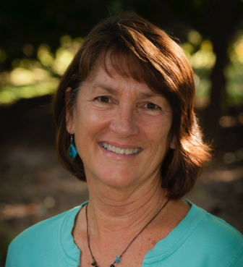

Renée Rosario, MA, LPC, is a transpersonal, body-centered psychotherapist in private practice in Boulder. She is a core faculty member of The Narrative Enneagram and has been teaching for eighteen years. Renée utilizes mindfulness practices and the Enneagram in her role as therapist.

